**Article ID:** 1129

**Article Name:** How to clean the rubber seal of my washing machine.

**Topic Location:** Laundry / Washing machine / Cleaning & Maintenance

**Meta-data:** dirt, gasket, sleeve

**Related Articles:**

**Related Questions:**

PNC

DIY

Safety

Link

Email

Book Engineer

Multimedia

Brand

**Article Content:**

**Causes:**

Constant low temperature washing cycles and the excessive use of liquid detergents (enzyme based) can cause mould and gelatinous dirt to build up in the door seal, pipes and drum. They can block up hoses, can cause bad odours in the washing machine and may leave even deposits on your laundry.

This can be caused by using too much detergent, or regularly washing at a low temperature. If you only do washes at 40°C or below, there will eventually be a build-up of residues from detergent and dirt in the washing machine. This can cause dirt, stains or grease on the seal.

**How to clean door seal or internal parts in washing machine**:

Run a number of wash cycles at 90°C, without any laundry, but with a cup of sodium carbonate (Sodium carbonate irritates skin and mucous membranes. Please use it with extreme caution!) in the drum, to clean the seal. We also suggest that you regularly clean the door seal to avoid dirt build up and leave the door slightly open at the end of the programme.

You can use our special Electrolux cleaner for washing machines:

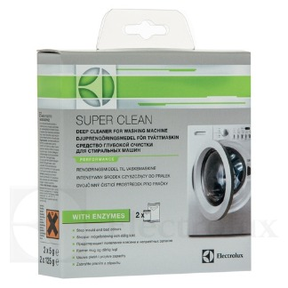

To buy this cleaner please follow the link to our webshop:

<http://shop.electrolux.co.uk/product/9029792786/Super-Clean+Washing+Machine+Cleaner>